**Experiment No # 01**

**Experiment Name # Linux Setup(Linux Mint)**

**Aim and Objects:**

The aim of Linux Mint is to provide a desktop operating system that home users and companies can use at no cost and which is as efficient, easy to use, and elegant as possible. One of the ambitions of the Linux Mint project is to become the best operating system available by making it easy for people to get to use advanced technologies, rather than by simplifying them and thereby reducing their capabilities, or by copying the approaches taken by other developers.

* To offer excellent security for the users
* To be designed for everyone and can be used by anyone.
* To be the best system to adopt as windows get slower days after days.
* To become the best way to transform the serving experience.

**Experiment Setup:**

1. After creating a bootable media, insert into a working USB port or DVD drive and boot into it, then, after a few seconds, we should be able to see the screen below and finally a live **Linux Mint 16** desktop.

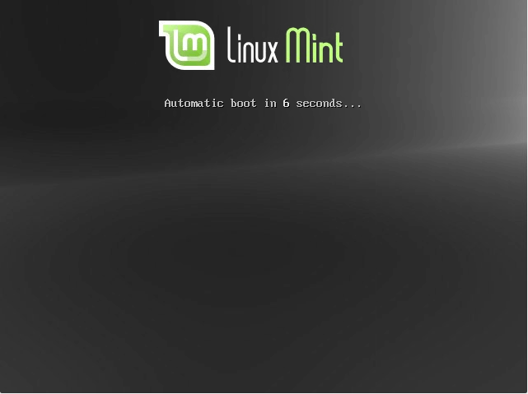

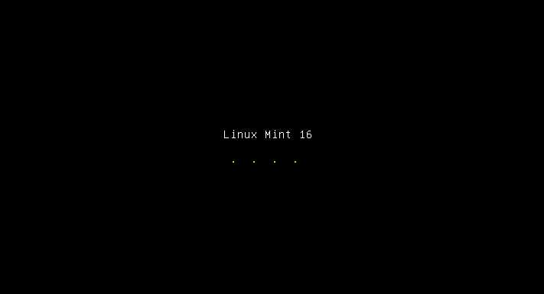

1. Double click on “**Install Linux Mint**” installer icon to start the installer.

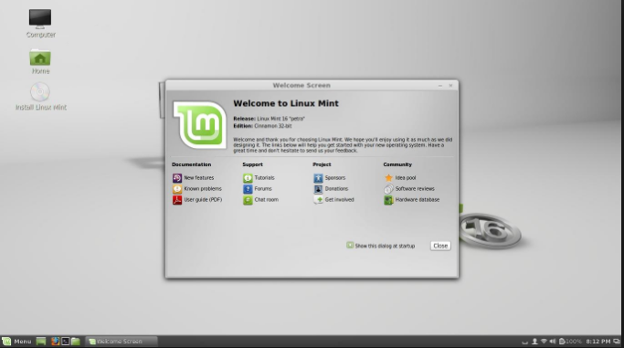

1. Then the welcome screen below, we have to select the installation language and click on “**Continue**” button.

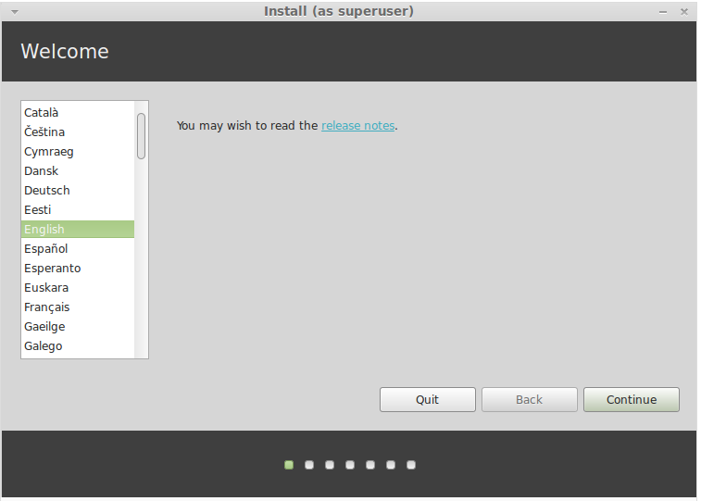

1. Then prepare to start the actual installation process. After that, click on the “**Continue**” to proceed.

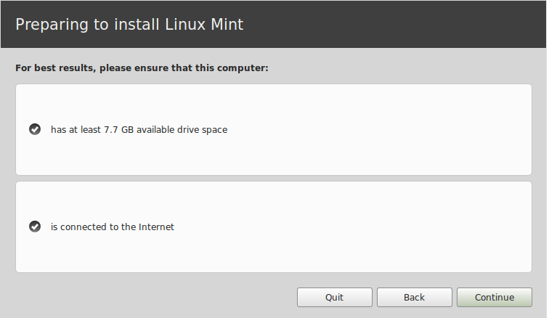

1. After completing all tasks the actual system files will now be installed on root partition as in the screen below.

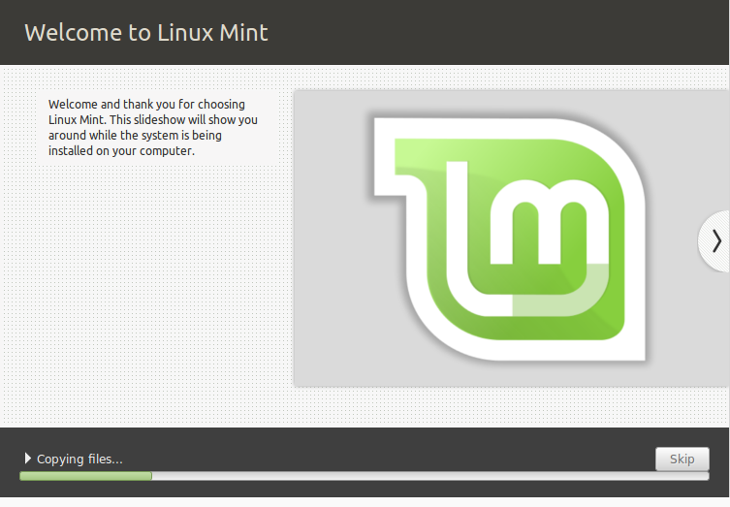

1. We have to wait until the installation process is complete, Next remove the installation USB/DVD and then, click “**Restart Now**” to reboot the machine.

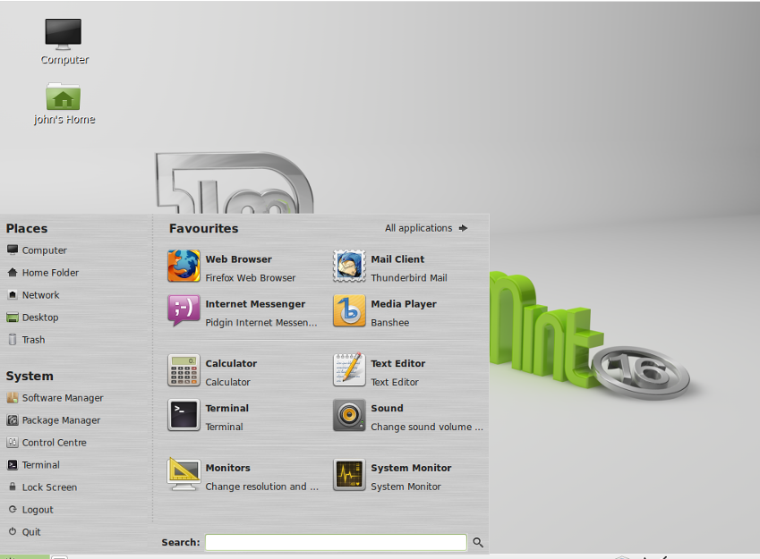

**Linux Commands:**

We have to use the Terminal to write commands. The commands are given below :

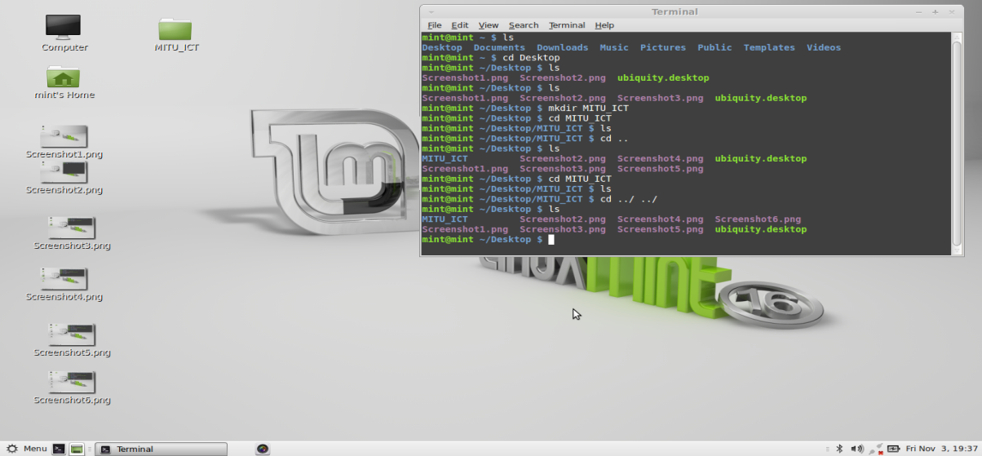

**Conclusion:**

Linux is a very popular Unix like operating system. Initially it was developed for personal computer, but due to its some fantastic features and robustness, it is used in with various hardware. Currently Linux is a very popular operating system for servers. Linux is open source version of Unix. Linux kernel code is available for public. One can take Linux kernel code and modify it by own ways and create own operating system. This is the beauty of Linux.

